**Day 6 Assignment - 09/12/2023 - Vamsi Viswanadham**

Worked on the below concepts.

* Database Basics & Schema

**Database Schema:** A database schema is a logical structure representing how data is stored in a database. It includes tables, fields, views, relationships, primary keys, and foreign keys, and provides a blueprint for how data is organized and interrelated.

**Types of Database Schema:**

* Physical Database Schema: This details how data is physically stored on disk or storage systems, including files and indices.
* Logical Database Schema: This involves logical constraints applied to stored data, such as integrity constraints, views, and table structures. It includes entity-relationship (ER) modeling to demonstrate data relationships.
* View Schema: This is the end-user interface of the database, describing how users interact with the database system.

**Difference between Physical and Logical Database Schema:** Physical schema doesn't include attributes and focuses on physical storage, while logical schema includes attributes, table and column names, data types, and focuses on how data is logically organized.

**Database Schema vs. Database Instance:** Database schema is a static blueprint of a database's structure, while a database instance is a snapshot of the database at a specific point in time.

**Creating Database Schema:** Different DBMSs have different methods for creating schemas. In MySQL, `CREATE SCHEMA` creates a database; in Oracle, it's more about managing existing schemas; in SQL Server, it creates a new schema.

**Database Schema Designs:**

1. Flat Model: A simple, two-dimensional array-like structure.
2. Hierarchical Model: A tree-like structure with one-to-many relationships.
3. Network Model: Similar to hierarchical but allows many-to-many relationships.
4. Relational Model: Stores data in tables with relations.
5. Star Schema: Organizes data for efficient analysis, focusing on facts and dimensions.
6. Snowflake Schema: An extension of the star schema with additional layers of dimension tables.

* **Functions and Creating Sub-Totals**

Here is a screenshot of the work

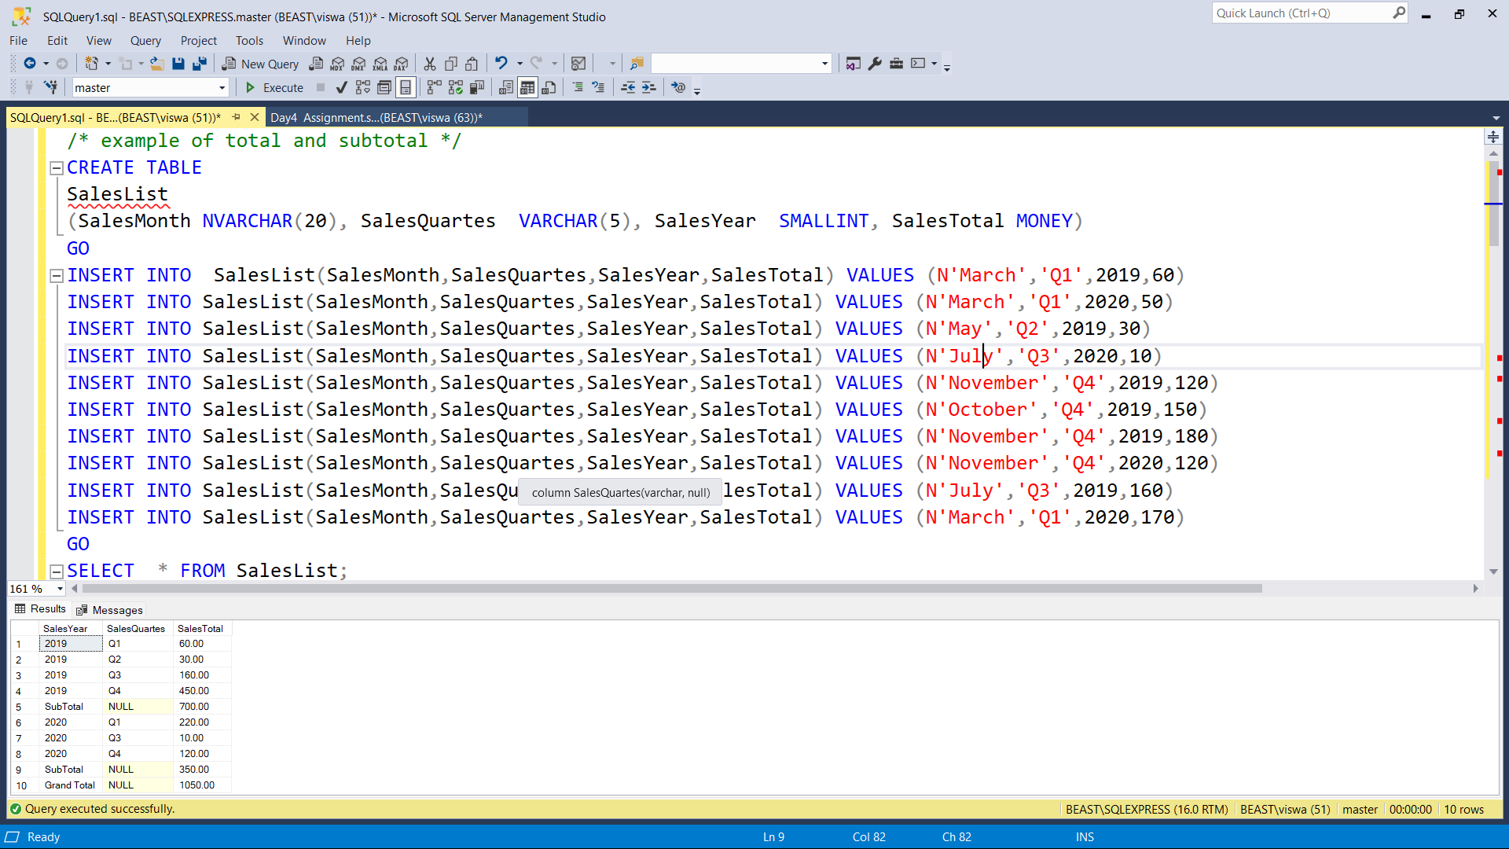

* **Stored Procedure**

Here is a screenshot of the work.

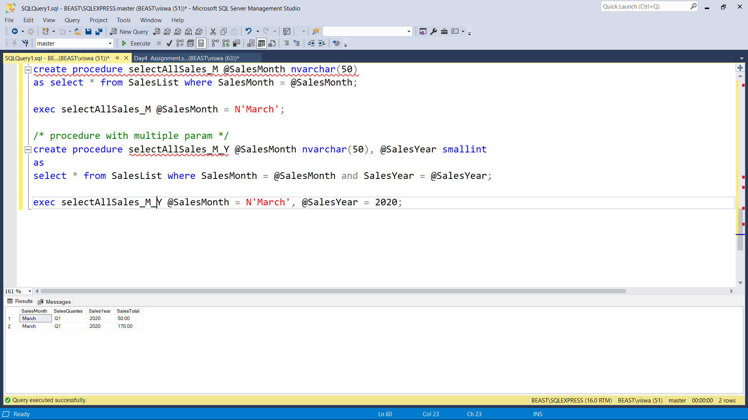

Here is a [SQL file](https://drive.google.com/file/d/10In5tNz-9S3dsmokNtfd5Wk0mrQBD-zw/view?usp=sharing) of the work.